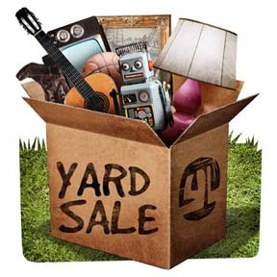 Chewsville Community

Fall Fest / Yard Sale

Bethel U.M. Church

21006 Twin Springs Drive, Smithsburg, MD 21783

Saturday October 5, 2024 8am-2pm.

Proceeds to benefit a new furnace!

Rent a space &/or rent a table- $10/each.

Donate items for the church to sale-dropoff anytime.

Call 301-733-8387