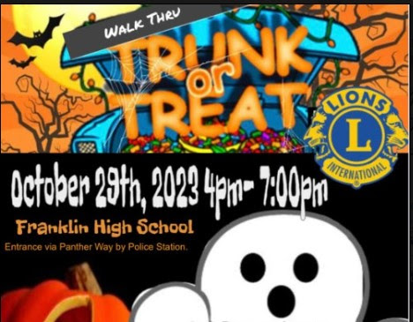**Fri. Oct 25 5-7pm**

**Bethel & New Beginnings Churches with the Lions of**

**Chewsville**

**Free food, Costume contest @ 6:30.**

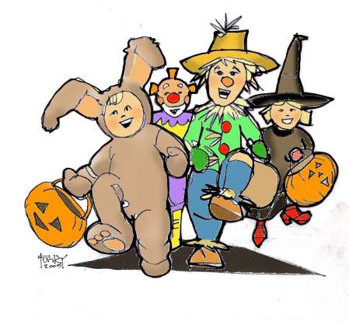**301-733-8387**