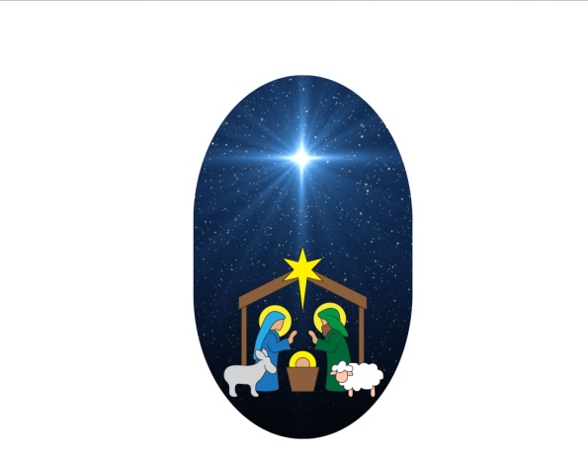

**Drive-Thru Live Nativity**

**December 21, 2024**

**5-7 PM**

Benevola United Methodist Church

19925 Benevola Church Road

Boonsboro, MD 21713

301-791-3576

**FREE Event — goodies for the kids**

**Gift Bag for each vehicle**

**(while supplies last**)

Rain/Snow Date:

December 22, 2024

5-7pm

Follow us on Facebook

www.benevolaumc.com