**Sunday, September 15, 2024, 3:00 PM** 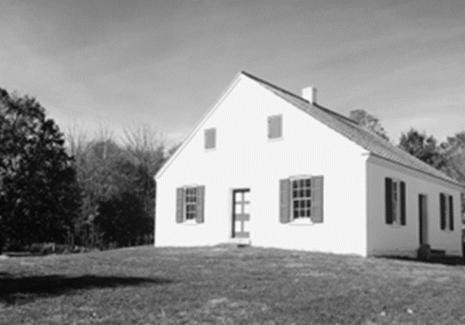

54th Annual

**Dunker Church Service**

*at the little white “Dunker Church” on the*

**Antietam National Battlefield, Sharpsburg, MD**

Guest Speaker

Gene Hagenberger

*“The Undiscovered Country“*

Gene Hagenberger has pastored congregations of the Church of the Brethren and served as Mid-Atlantic District Executive Minister from 2009-2022. Since 2023 he does NPO fundraising.

Special music: Back Row Singers, Hagerstown CoB

Carol Scheppard, bagpipes Adam Lane, vocal/guitar

All are welcome to worship with us.