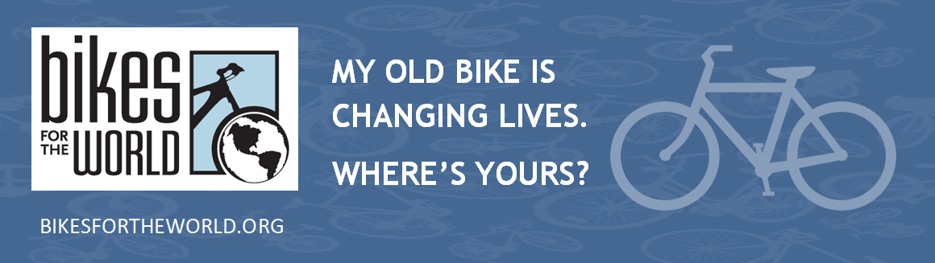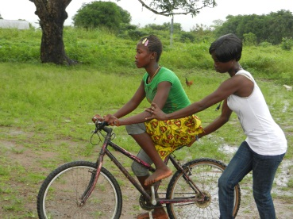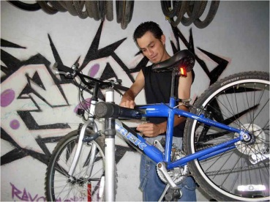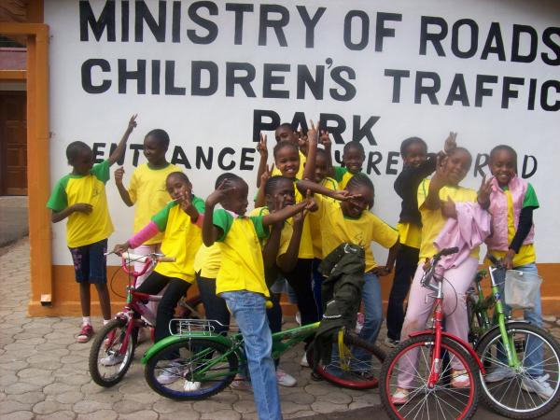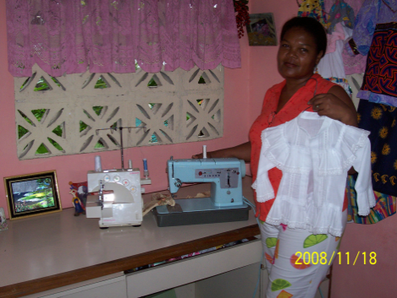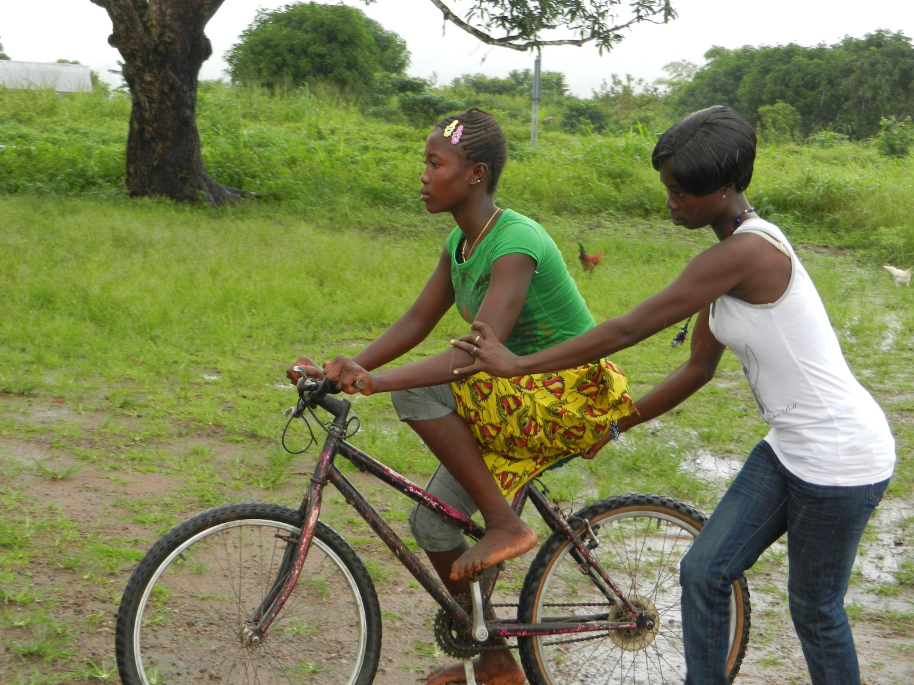

Saturday April 27 9am—12pm

**20th Annual Collection!**

**Otterbein United Methodist Church**

108 E Franklin St

Hagerstown MD 21740

301-739-9386

Contact info:

Cindy or Mike

cindybrownsr@gmail.com or mike@msjohnston.com

mike1@msjohnston.com or 301.331.9153

***Re-Cycle***

***Re-Use***

**UPCOMING**

**BICYCLE COLLECTION**

**PUT YOUR OLD BIKE or SEWING MACHINE TO GOOD USE**

Help someone get to work, school and health services.   
**DONATE IT HERE:**

**A $10 per bike donation is suggested to defray a share of the**

**cost of shipping to overseas charity partners, which recondition**

**the bicycles and distribute them to people who need them**

**to get to work, school, and health services.**

Bikes for the World is a a 501(c)(3) non-profit charity. A receipt

will be provided for all material and cash donations. Checks accepted.

**office@bikesfortheworld.org 703.740.7856**