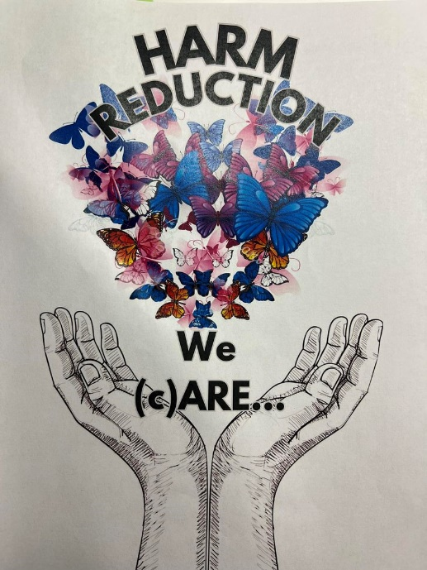

Voices of Recovery and Resilience: Harm Reduction

Tuesdays at 4:15 -5:15pm
Followed by meal at 5:30

February 13 - March 19
Otterbein United Methodist Church
108 E. Franklin St.
Hagerstown, MD 21740

Powerful personal testimonies presented weekly. Hear stories of addiction and struggle to recovery. Community voices, programs, resources, and peer support presented and coordinated by

David Washington, LCADC, LCSW-C, AD/PC Sup., Wash Co Health Dept.
Alicia Le Bon, Sr. Community Outreach Specialist Ctr of Substance Use & Infectious Diseases Care, JHU School of Medicine

Link to registration: https://www.otterumc.org/gracegrazegrow

