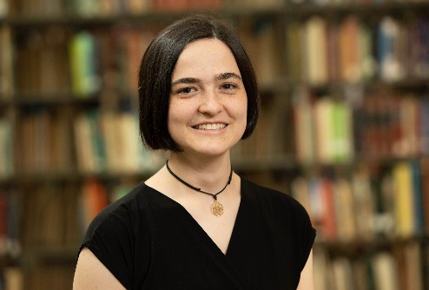
Hebron Mennonite Church welcomes new pastor, Anna Ressler
Pastor Anna Ressler from Kidron, Ohio begins her ministry at Hebron Mennonite Church on Highlane Street in Paramount on September 1. She graduated from Anabaptist Mennonite Biblical Seminary in Elkhart, Indiana in 2023 with a Master of Divinity degree. She majored in Pastoral Ministry and received the seminary’s award for Excellence in Biblical Interpretation.
When asked what drew her to the Hebron congregation, Ressler said, “One of the things that caught my attention was the name – Hebron – and the idea behind it of being a place of refuge. It struck me as exactly what the Church should be, and what I want my church to be – a place of refuge. As I learned more about the congregation, not only did they seem to beautifully embody that identity but nearly everything else (from the size, to the worship style, to the community garden) seemed like a good fit for me.”
Mike Martin, co-chair of Hebron’s search team, noted: “As a search team, we were impressed with Anna's speaking and storytelling skills. With each interaction during the interview process, we became more convinced that Anna and our congregation and community would be a good fit together. We look forward to the creativity and energy she brings.”
Ressler added: “I look forward to interacting with other communities of faith in the Hagerstown area (I’ve heard a lot of great things about HARC) and possibly participating in community theatre or choir.”
Ressler grew up in the Sonnenberg Mennonite congregation where from an early age she was encouraged by her family and congregation to lead in worship in many ways. She attended Eastern Mennonite University (EMU), graduating with honors in 2020, receiving a Bachelor of Science in Psychology with a minor in Neuroscience. While in college, she participated in various music events and theater productions, as well as spending a semester in the Middle East as part of EMU’s Cross-Cultural program.
Pastor Anna is an avid baker and Biblical storyteller. She enjoys acting, singing, hiking and dark chocolate. Her first sermon as pastor at Hebron will be on September 10. The congregation eagerly anticipates learning to know her through her ministry here.
Sunday worship at 13315 Highlane Street begins at 10 am, with coffee and fellowship time from 11-11:30, followed by a second hour from 11:30-12:15 with discussion for adults and classes for children. The 10 am service is streamed on the “live” tab at https://www.youtube.com/channel/UCuzq-91FZKd8MXVYqbsC8og.
Hebron Mennonite Church is a community that believes in Jesus’ call to love and welcome all people. www.hebronhag.net

