Choral Concert
presented by
The Chapel Choir of Saint James School
Linda Morgan Stowe, Director
John Chappell Stowe, Visiting Organist;
Roderick Demmings, Visiting Artist;
Valerie Zumbrun, violin; Teresa Shang, flute; Tsz Chiu Cheung, piano

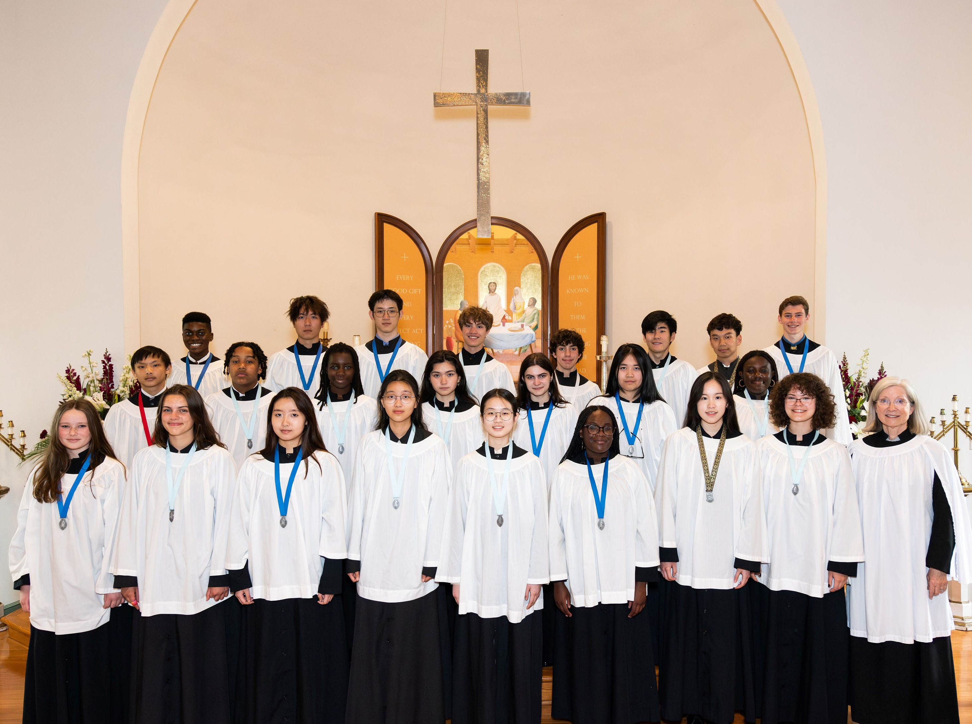
Composers of Repertoire
Felix Borokowski, Richard Wayne Dirksen, Herbert Howells, Gerre Hancock, Bob Chilcott,
Frédéric Chopin, Moses Hogan, Andre Thomas, Charles Albert Tindley, Robert Ray

Thursday, May 18, 2023 at 7:30 p.m.
Saint John’s Episcopal Church
101 South Prospect Street ~ Hagerstown, Maryland 21740 ~ 301-733-2560 x 108
Parking in the church lot at the corner of Walnut and Antietam Streets

