FISH Fry
Saturday April 22, 2023
11AM until sold out!
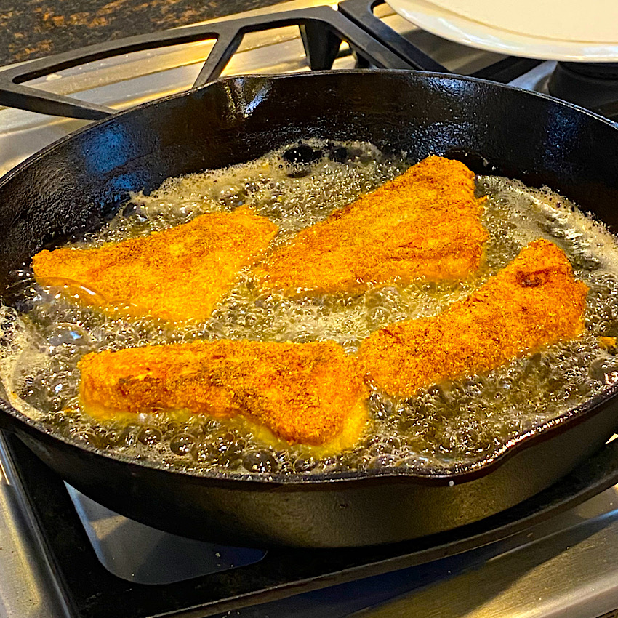
Menu
Fish
Green beans
Bake macaroni & cheese
Dessert and drink
Donation $10

Sponsored by Asbury UMC, Hagerstown, MD. Finance Committee
Contact number: 301-305-8166

