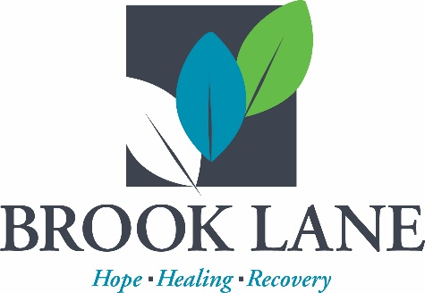

FREE Facebook Live Event

Teenagers and Drug Use:
What You Need to Know
January 24, 2023 - 6:30 pm to 7:30 pm

http://www.facebook.com/brooklaneinc
Substance use has always been a dangerous
threat to our youth. But, with the prevalence
of prescription drugs in the home, availability
to purchase illegal drugs off the street, and
the increased potency of synthetic opioids
like fentanyl, there has never been a time
more dangerous than now for our children.
Not only can drug use affect brain develop
ment and growth, but it also can lead to
risky behaviors that could contribute to physical and mental health issues, including unwanted pregnancies, violence, bullying and even suicide. Join Vicki, Holly and Ron as they discuss the latest updates on the drug scene and what you can do to help prevent your children, students, neighbors and friends from getting involved.

Featuring:
Vicki Sterling, LCSW-C, Director of Behavioral Health Services
Washington County Health Department

Holly Luther, Prevention Program Coordinator
Washington County Health Department

Ron Issacs, Agent, Washington County Narcotics Task Force

Questions: curt.miller@brooklane.org or 301-733-0331 x1228

