NEW YEAR EVENTS 2023
All events at St. Mark’s Fellowship Center, 18313 Lappans Road, Boonsboro
www.unityhagerstown.org
QUESTIONS? Call Sandy @ 240-409-5940 or send email to: unityhagerstown@gmail.com

For more information, 240-409-5940 or
unityhagerstown@gmail.com
www.unityhagerstown.org
18313 Lappans Rd., Boonsboro
For more information, 240-409-5940 or
unityhagerstown@gmail.com
www.unityhagerstown.org
18313 Lappans Rd., Boonsboro
New Year’s Sound Bath  January 4 / 7 pm / $20  Set your intention for the New Year with guided meditation, crystal singing bowls, drumming, Native American flute, and other beautiful sound healing instruments. Relax, heal, clear and release energy, connect more deeply with your own inner knowing, and embody more of your truth, with SABRINA MADSEN  - Bring a yoga mat, blankets, and whatever you need to lay comfortably to relax and receive sound healing. Chairs will be available. |  |  | 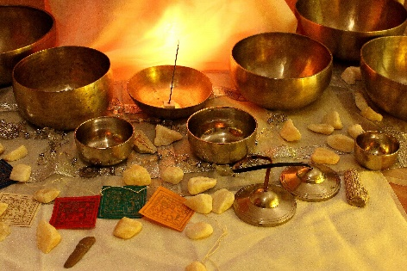
Vision Board
January 15 / 12:15 pm / $15
Create a beautiful collage of your vision for 2023! Homecooked vegetarian lunch and materials provided. Bring magazines, photos and other cool stuff to include in this powerful manifestation tool to personalize! RSVP- unityhagerstown@live.com by 1/14/23

Underground Swamis Spiritual Song Concert
January 20 / 7 pm / $20
Spreading a message of love and gratitude in harmony! Tracey and Joe provide a beautiful space for the heart to grow through music. With original songs, standard hymns and mantras, this promises to be a very special evening. Pay at the door.
Movie Night
January 27 / 7 pm / $20
Three-Hundred-Twenty acres of sacred land filled with old-growth forests, meadows, lakes, and hills, the vistas, colors, textures, flora and fauna, and the animals that live and teach truths, just being discovered by human science. This film follows an 8-day ‘Equinisity’ retreat on the healing presence of animals. Light supper included. RSVP unityhagerstown@live.com by 1/26

Burning Bowl Service-release what no longer serves you
Jan. 1, 2023 / 11am
White Stone Service-claim the quality you want to embody for 2023
Jan. 8, 2023 / 11am

