Wellness Weds. In November with Unity of Hagerstown
Sound Bath Wed. Evening 11/2 7-8:30 p.m.
Experience a sound bath with guided meditation, crystal singing bowls, drumming, Native American flute, other beautiful sound healing instruments, with Sabrina Madsen. Relax, heal, clear & release energy, connect more deeply with your own inner knowing, and embody more of your truth. $20

What to bring:
-Yourself, as you are.
-Yoga mats and blankets; whatever would make you feel comfortable as we relax and receive sound healing.
-Water
-Journal and pen
-Consider bringing an item you would like charged with your intentions/healing from the sound bath. You could also bring an item that represents one of the elements that might be resonating with you currently: fire, earth, water, or air. This can also be an offering that you can later give back to the Earth (a flower, crystal, etc.).
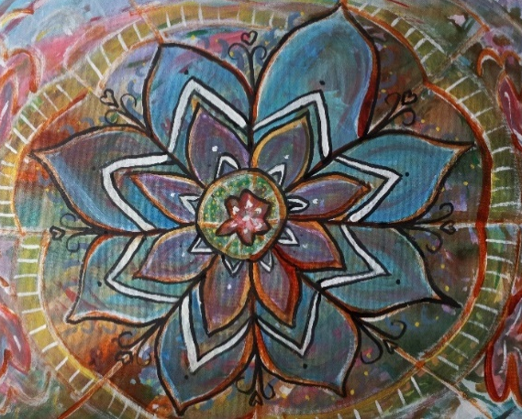
Paint a Mandala Wed. Evenings 11/9 & 11/16 6:30-8 p.m.
One of the oldest meditation tools, a mandala is also used to focus one’s desires to bring into manifestation. Part meditation, part creative self-expression, participants will paint a beautiful mandala…no painting experience necessary. Tuition-$40 Registration required by email- unityhagestown@gmail.com
Materials to bring- 24" x 24" square canvas, or at least 20" x 20"Acrylic paints nothing fancy, just a beginner’s kit
Paint brushes: size 2 and size 10

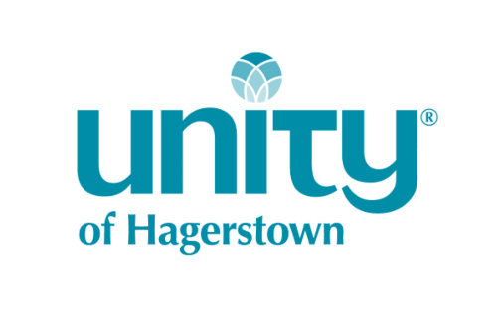
For more information, 240-409-5940 or unityhagerstown@gmail.com
www.unityhagerstown.org
18313 Lappans Rd., Boonsboro MD

