Beginning T’ai Chi Classes
Otterbein United Methodist Church
Wednesdays Starting September 14th
5:00 – 6:00 p.m.
Recommended Donation - $5 Per Class

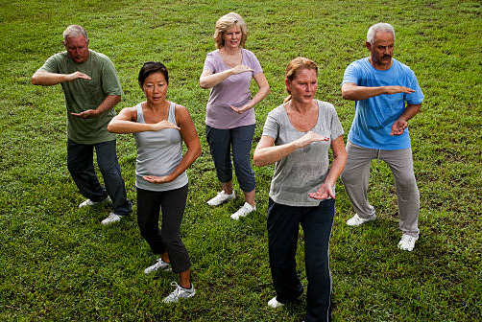
In-Person Classes
Otterbein UMC at 108 E. Franklin Street, Hagerstown

This beginning course in T'ai Chi is designed especially for the novice, of any age, who wishes to learn a simplified version of this profound art form. The art of T'ai Chi is taught as a holistic exercise that promotes health, improves balance, and enhances mind-body awareness. Step-by-step instruction is provided in an easy-to-learn format of less than 20 movements. The movements of T'ai Chi are performed slowly and relaxed with concentration and control. No previous experience is necessary. Wear comfortable clothing and flat-soled shoes. Masks will be optional, depending on COVID rates in Washington County. Exclusions apply for pregnant women and those with severe arthritis in the knees.

Instructor - Paul Cote
Paul has spent the past 35 years teaching and exploring T’ai Chi in connection with improved body management and as a holistic health practice. Paul is a retired university professor and has taught T’ai Chi at Hagerstown Community College since 2007.

3 Ways To REGISTER
Go to the Connect menu at https://otterumc.org/taichi
By e-mail to office@otterumc.org
Call the church office at 301-739-9386

