Second chances
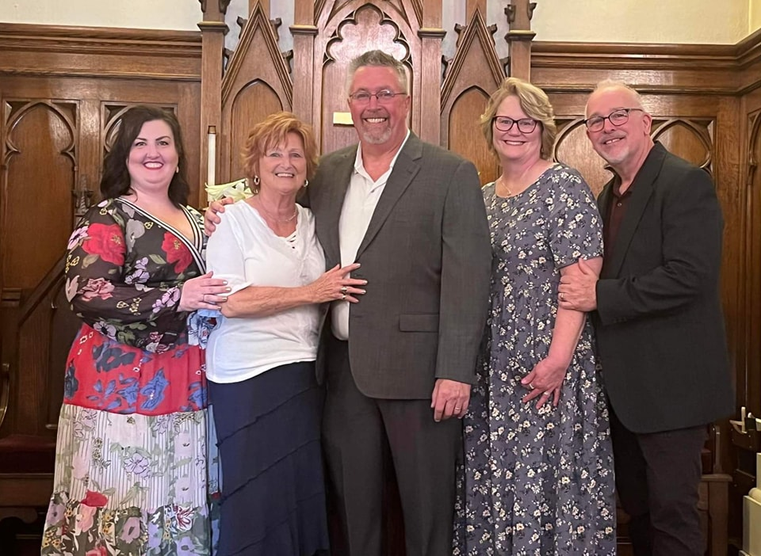
in concert
Sunday, Sept. 11
4:00 pm
Classical, Gospel & Traditional Hymns
John Wesley United Methodist Church
129 N. Potomac Street
Hagerstown, MD

301-733-0391

Freewill Offering – Reception Following

