“WELCOME FRIENDS” MISSION
“…I WAS A STRANGER, AND YOU WELCOMED ME…”
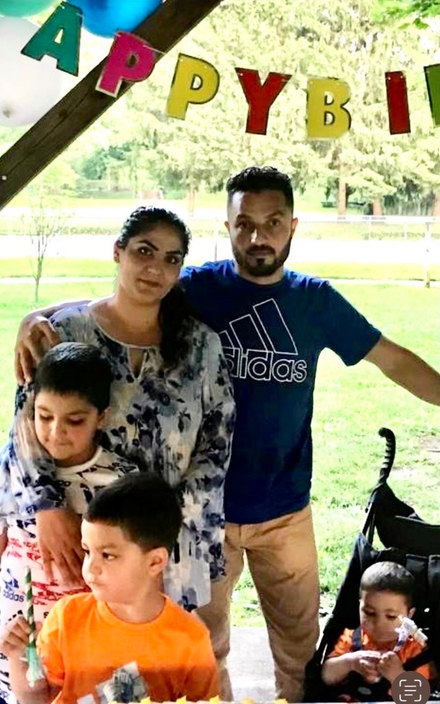
Please join us at Trinity Lutheran Church in our new mission of welcoming to our community Malalai and Mustafa Nawabi and their three small sons: Maheer (6), Mehram (3), and Maher Tash (1). They fled Afghanistan in August of 2021 as the Taliban took control of their country, literally leaving behind all their possessions and their extended family in order to provide a safer, more just environment for their children.

Malalai came to our church because of our community outreach programs, and she soon became a friend to many of us in the Food Pantry and Clothing Closet. She desperately wants a better life for her family and is trying hard to make their resettlement here as pleasant as possible for the boys. She is now working at the YMCA, and Mustafa is learning English so that he may also be employed soon. Malalai is proficient in English; she and Mustafa both speak three other languages. Through our mission, we have assisted them with job opportunities, private pre-school through grant money, bus passes, bicycles for the older boys, air conditioners for their apartment, baby equipment, transportation to Frederick for appointments, and a shopping trip for new clothes.

Their current most pressing need, however, is obtaining asylum. Our U.S. customs and immigration system has an extremely complicated process for filing asylum applications. Unfortunately, the rate of success for asylum being granted is a mere 41%, and the application needs to be submitted within 12 months of arrival to the U.S. For this reason, our church has hired an immigration lawyer to improve their outcome. Although the Nawabis have been assisted with housing and other basic necessities by Lutheran Immigration and Refugee Services, there was no assistance offered by them in terms of legal services. Non-profits and pro bono lawyers were contacted by our mission team; however, these organizations are all overwhelmed and were unable to assist us in the time frame necessary. Our church has now paid for two thirds of the lawyer’s costs ($4,000); however, we remain short on funds ($2,000 still needed). For this reason, we respectfully request that you prayerfully consider donating to this worthy cause. Checks may be made out to: Trinity Lutheran Church; 15 Randolph Ave.; Hagerstown, MD 21740. Please write “Refugee Family” on the memo line of the check.

Years ago, as the Syrian refugee crisis began, our church’s efforts to adopt a Syrian family were thwarted. As the terrible Ukrainian invasion unfolded this Spring, we once again wondered how we could be useful. Then, God literally deposited this lovely Afghan family- also refugees- on our doorstep. How can we not be compelled to answer His call?

Thank you in advance for your generosity and support. More than anything, thank you for your prayers for these brave and good people, especially that asylum may be granted to them. And thank you for welcoming them to our community.

Trinity Lutheran Church Congregational Council

