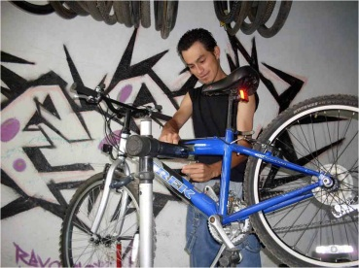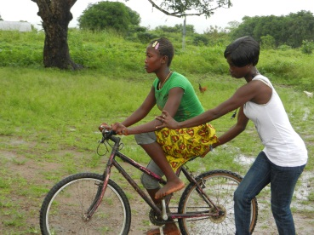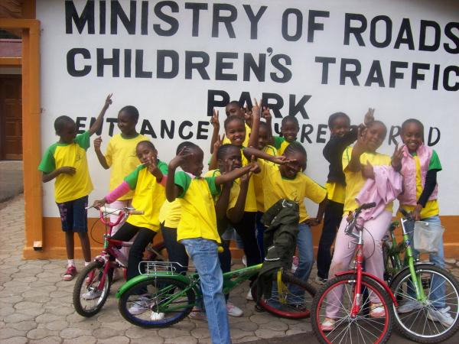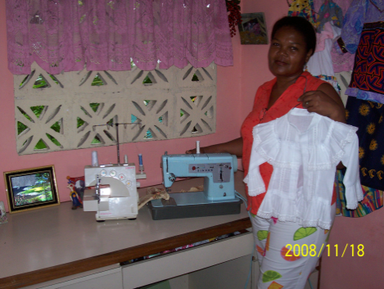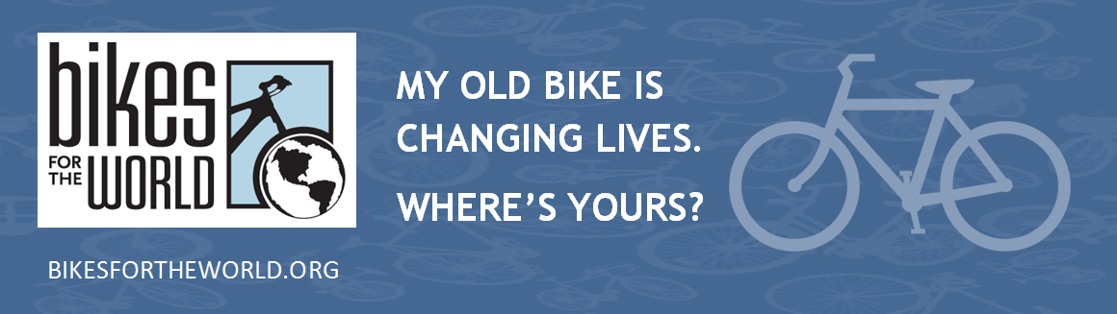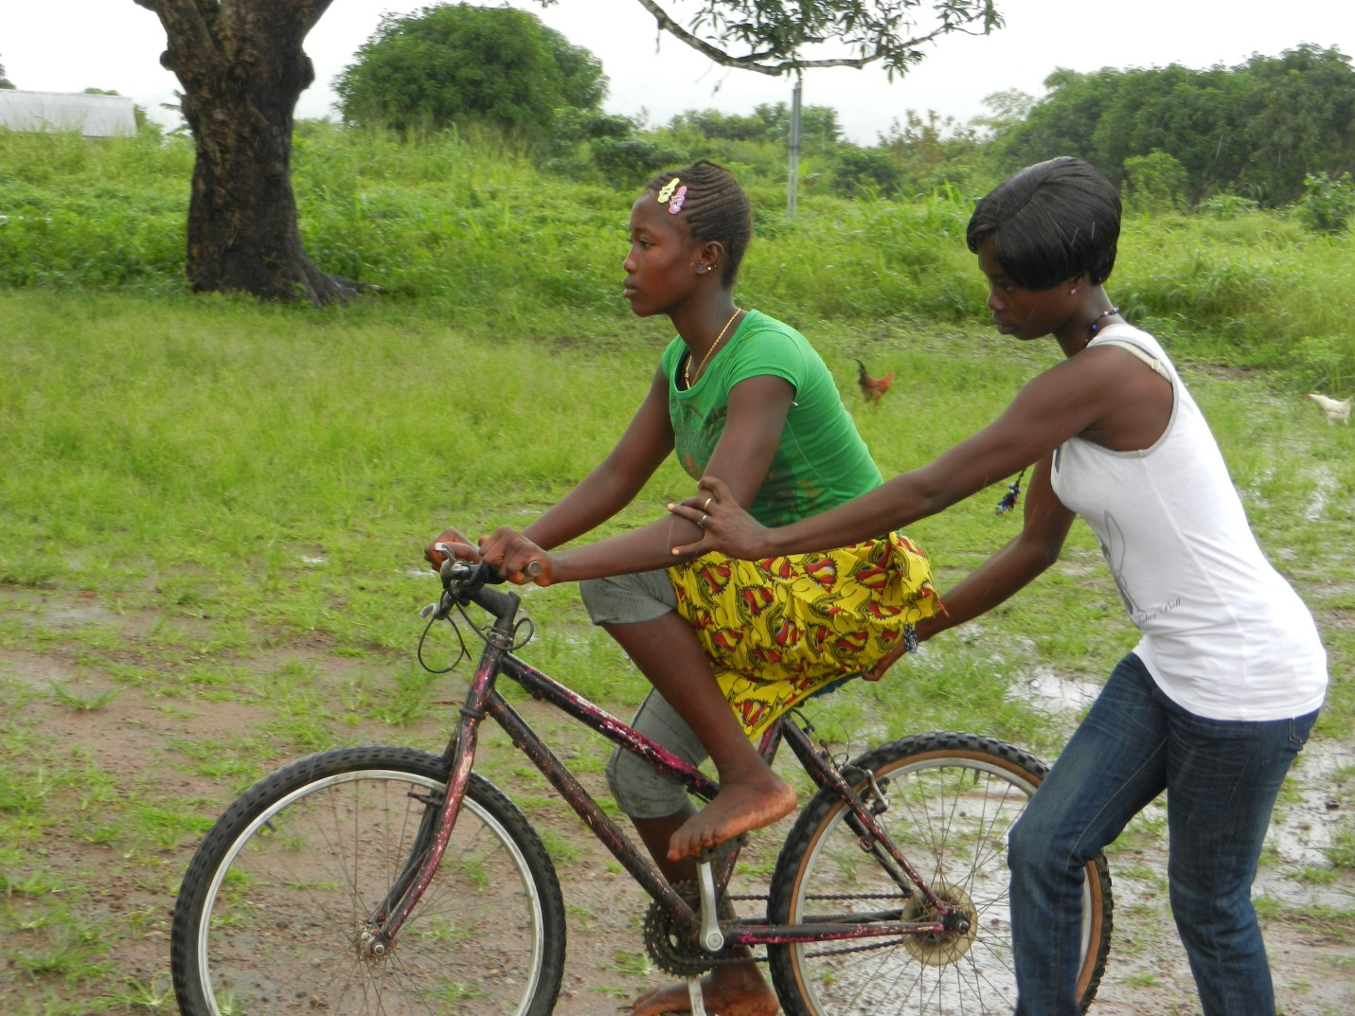

***Re-Cycle***

***Re-Use***

**2022**

**BICYCLE COLLECTION**

Saturday April 30 9am—12pm

**Otterbein United Methodist Church**

108 E Franklin St

Hagerstown MD 21740

Contact info:

[office@otterumc.org](mailto:office@otterumc.org) or 301.739.9386

[mike1@msjohnston.com](mailto:mike1@msjohnston.com) or 301.331.9153

**PUT YOUR OLD BIKE or SEWING MACHINE TO GOOD USE**

Help someone get to work, school and health services.   
**DONATE IT HERE:**

**A $10 per bike donation is suggested to defray a share of the**

**cost of shipping to overseas charity partners, which recondition**

**the bicycles and distribute them to people who need them**

**to get to work, school, and health services.**

Bikes for the World is a a 501(c)(3) non-profit charity. A receipt

will be provided for all material and cash donations. Checks accepted.

**office@bikesfortheworld.org 703.740.7856**