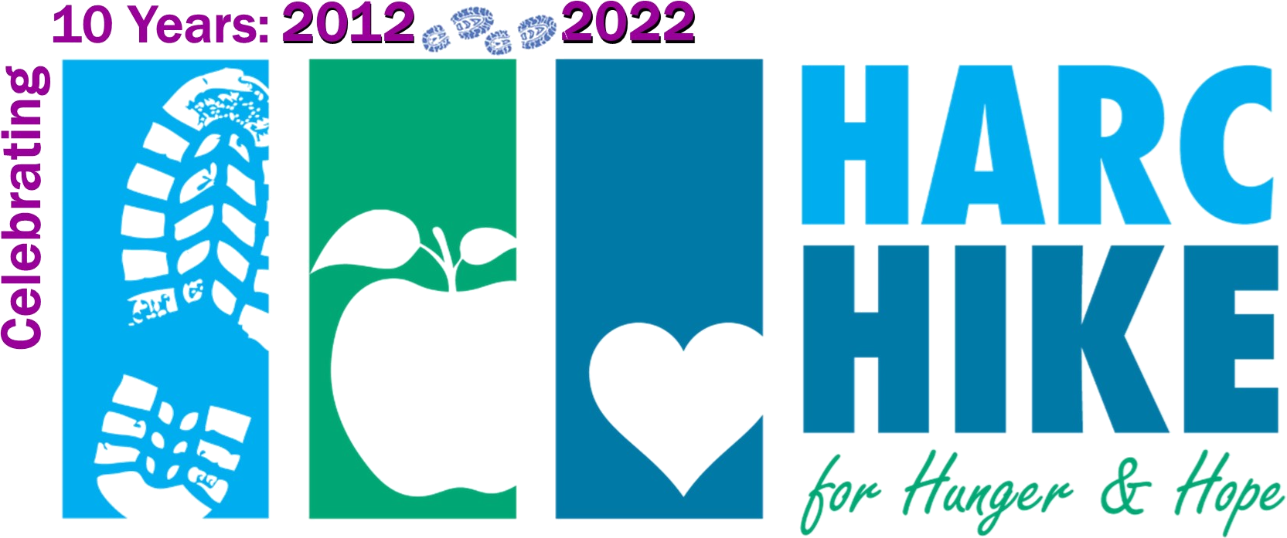
Sponsorship
opportunities

10th Annual HARC Hike
for Hunger & Hope
Saturday, June 4, 2022
www.harccoalition.org/hike

Friend $100
SPONSORSHIP LEVELS  & BENEFITS: | Titanium  $2,000 | Lunch  $1,200* | Platinum  $1,000 | Gold  $500 | Silver  $250
Company logo on event t-shirt | At the top | √ | √
Company name on event t-shirt |  |  |  | √ | √
Display your banner/sign at event | √ | √ | √
Your card or promo piece included with each lunch | √ | √
Promotion on Social Media | √ | √ | √ | √
Logo on event emails & web page with link to your website | Top billing | √ | √ | √ | name only
Inclusion in press releases related to the event | Top billing | √ | √
Number of free event t-shirts  Number of free event entries | 4  of each | 4  of each | 4  of each | 2  of each | 1  of each

sponsorship
level includes listing on Hike web page

* Lunch sponsor supports a
local, minority- owned business!



HARC Hike Sponsorship Form

Sponsor Name as you’d like it to appear

Contact Name Phone

Mailing Address

Email Address Sponsorship Amount:

T-shirt size(s), if desired: Number participating in Hike:

Sponsors Gold and above: Please email your logo to director@harccoalition.org
Deadline is 5/13/22 to be included on the event t-shirt.
Please make checks payable to: HARC ~ on the memo line of the check, indicate: “HARC Hike”
Mail to: HARC, P.O. Box 1158, Hagerstown, MD 21741-1158 ~ Thank you for your support!

