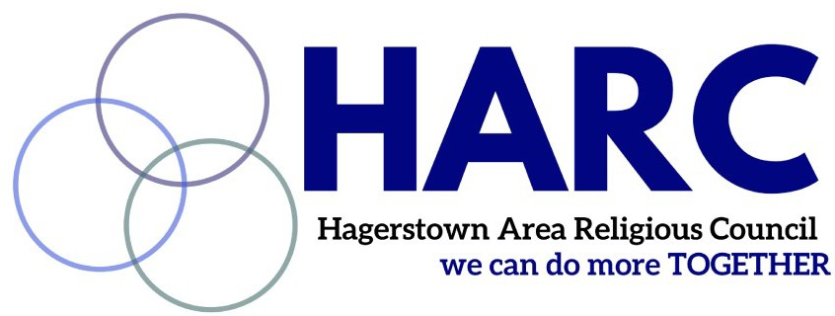
Our mission: To embody mercy, justice, and love as diverse faith partners in Washington County
www.harccoalition.org

2022 Mission Support

To assist HARC in its vital mission, I/we pledge to give in 2022:

o $ 7.50 o $37.50 o $75.00 o $175 o 375 o $750.00 o Other amount: ___________
(Suggested amounts are in increments of 75 in honor of the 75 years of service completed by HARC/Washington County Council of Churches!)

o monthly / o quarterly / o annually through the following method:

o e-giving:

Or visit https://www.harccoalition.org/donate

o Mail: HARC, P.O. Box 1158
Hagerstown, MD 21741
[Checks payable to: HARC]

o Contact me for other ways of giving

My/our contact information:
Name: _________________________________________________ Phone: ________________________
Email: __________________________________________________________
Mailing address: ________________________________________________________________________

Signature: ________________________________________________ Date: _______________________
(electronic signature OK)
Thank you for your commitment to sustain HARC in its mission to embody mercy, justice and love in Washington County, MD!

