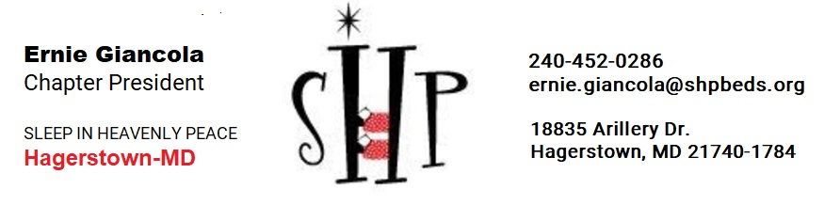
Help Us Build 50 Beds to help us with our goal that
“No Child Sleeps on the Floor in Our Town”!

Where: 87 West Lee Street, Hagerstown, MD (across the street from Ellsworth Electric)
When: Build - Saturday, November 20th, from 8:00 am to 12:00 pm (lunch at 12)
Unload Lumber - Wednesday, November 10th, from 5:00 pm to 8:00 pm
Pre-cut Lumber - Wednesday, November 17th, from 4:30 pm to 7:30 pm.

To sign up and register to volunteer Use this QR code to go to the URL below to start your signup:
https://www.signupgenius.com/go/10C0C45A4AB2BA6F4C16-november

Review the date/tasks and put a check in the “Sign Up” box for things you can help with.
When you have checked all your events, go to the bottom of the screen and Press “Submit and Sign up”. Add your First and Last name, and your email address and click “Sign Up Now”. Also, if you would let us know if you are with a particular school, church, business, or organization, it will help us better understand Who's Who. You’ll receive a confirmation email with the schedule of events you have signed up for.
We welcome any and all helping hands age 12 and up. Bring your gloves. Eye and hearing protection will be provided. Lunch, snacks, and water will also be provided.

We need new volunteers so if you know of anyone else who would be interested in volunteering, please pass on the invitation. You can use this build up you’re your community service points as well.
We as the team of SHP Hagerstown look forward to seeing many of you on November 20th to partake in this great experience.

