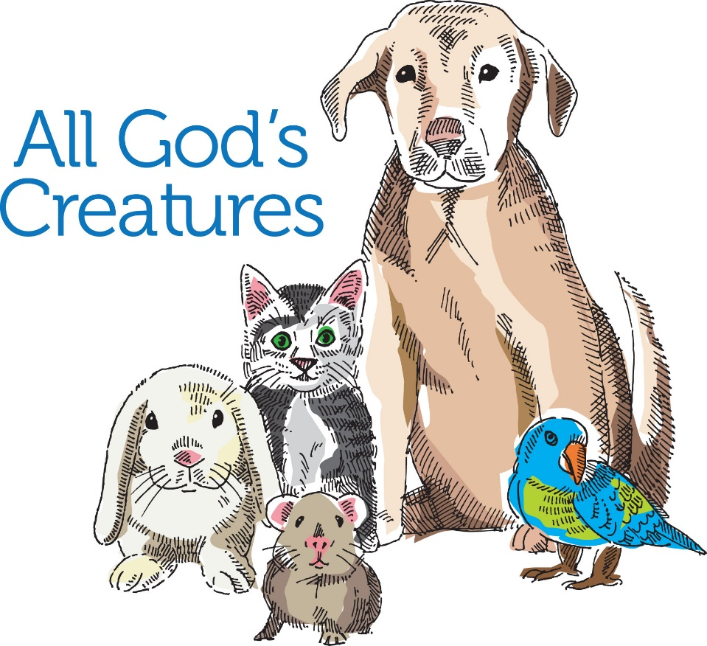
COME JOIN US

We are Blessing all of our 2 and 4 legged Animal Friends,
even the ones that swim and crawl.

Sunday, September 26, 2021 at 11:00am
Zion Reformed Church parking lot
201 N. Potomac St., Hagerstown
301-739-7244

Bring your pets or a photo of your pet!

