Music To Be Cool
Bach is Back!

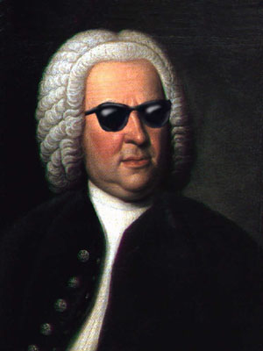
Local organists and instrumentalists
collaborate to celebrate the life of
Johann Sebastian Bach
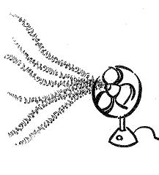
(1685-1750)
and make Bach cool!

SATURDAY, AUGUST 14, 4 p.m.
Trinity Lutheran Church, Hagerstown
For further information, please call 301-733-2878, ext 206
or check out our website, tlchag.org

