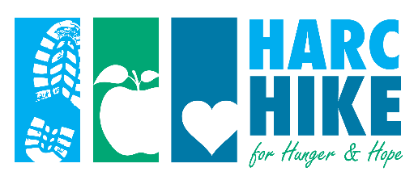
Sponsorship Opportunities
9th Annual HARC Hike for Hunger & Hope
Saturday, September 11, 2021

Lunch Sponsor - $1,200  Support a local, woman and minority owned catering business AND Micah’s Backpack and HARC  - Company logo on event t-shirt  - Display your banner or sign at celebration pavilion  - Your card or promo piece included with each lunch  - Promotion on social media  - Logo on event emails and web page with link to your website  - Inclusion in press releases related to the event  - 4 complimentary event t-shirts  - 4 complimentary event entries | Platinum Sponsor  $1,000  - Company logo on event t-shirt  - Display your banner or sign at celebration pavilion  - Promotion on social media  - Logo on event emails and web page with link to your website  - Inclusion in press releases related to the event  - 4 complimentary event t-shirts  - 4 complimentary event entries

Gold Sponsor  $500  - Company name on t-shirt  - Promotion on social media  - Logo on event web page with link to your website  - 3 comp. event t-shirts  - 3 comp. event entries | Silver Sponsor  $250  - Company name on t-shirt  - Company name listed on event web page  - 2 comp. event t-shirts  - 2 comp. event entries | Bronze Sponsor  $100  - Company name listed on event web page  - 1 comp. event t-shirt

Deadline is August 20, 2021 to be included on the event t-shirt.
Please complete below and return bottom portion to HARC with your donation.

HARC Hike Sponsorship Form

Sponsor Name as you would like it to appear ______________________________________________

Contact Name ____________________________________ Phone _____________________________

Mailing Address _____________________________________________________________________

Email Address________________________________________ Sponsorship Amount: _____________

T-shirt size(s), if desired: ________________________ Number participating in hike: ____________

Lunch, Platinum and Gold sponsors: please email your logo to director@harccoalition.org
Lunch, Platinum, Gold and Silver sponsors: deadline is 8/20/21 to be included on the event t-shirt

Please make checks payable to: HARC. On the memo line of the check please indicate: HARC Hike.
Mail donations to: HARC, P.O. Box 1158, Hagerstown, MD 21741-1158

