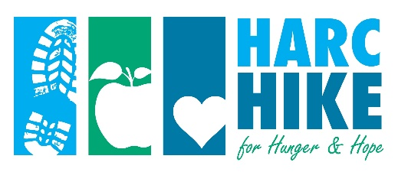
HIKER SPONSOR FORM

Get your friends and family to support your efforts and help raise funds for hunger relief and early childhood education and literacy work. Set a goal to raise a minimum of $200. Raise as much as you can — every dollar counts!

Mail donations to: HARC, P.O. Box 1158, Hagerstown, MD 21741-1158 (Please do not mail cash) or bring your donations to the Registration Station, along with this form, on the day of the event.

Your name ____________________________________________ Total donations ____________________

Name ______________________________________ Address ______________________________________

City ____________________ State _______ Zip ________ Check Cash Amount $____________

Name ______________________________________ Address ______________________________________

City ____________________ State _______ Zip ________ Check Cash Amount $____________

Name ______________________________________ Address ______________________________________

City ____________________ State _______ Zip ________ Check Cash Amount $____________

Name ______________________________________ Address ______________________________________

City ____________________ State _______ Zip ________ Check Cash Amount $____________

Name ______________________________________ Address ______________________________________

City ____________________ State _______ Zip ________ Check Cash Amount $____________

Name ______________________________________ Address ______________________________________

City ____________________ State _______ Zip ________ Check Cash Amount $____________

Name ______________________________________ Address ______________________________________

City ____________________ State _______ Zip ________ Check Cash Amount $____________

Make checks payable to HARC. Attach additional donations on a separate sheet or make copies of this donation collection form. Questions? Contact Kathy Powderly at kathy.harc@gmail.com or 301-842-4272

