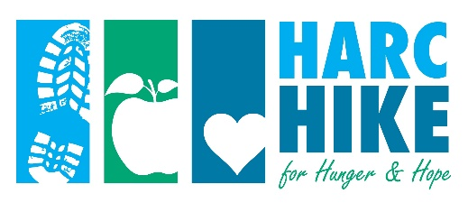
HIKER SPONSOR FORM

Get your friends and family to support your efforts and help raise funds for hunger relief, early childhood education and literacy work, and other collaborative efforts of the faith community. Set a goal and raise as much as you can — every dollar counts!

Mail donations to: HARC, P.O. Box 1158, Hagerstown, MD 21741-1158 (Please do not mail cash) or bring your donations to the Registration Station, along with this form, on the day of the event. All donors with address listed will receive a Thank You letter for tax purposes. Our online fundraising option is also easy to use!

Your name ____________________________________________ Total donations ____________________

Name ______________________________________ Address ______________________________________

City ____________________ State _______ Zip ________ Check Cash Amount $____________

Name ______________________________________ Address ______________________________________

City ____________________ State _______ Zip ________ Check Cash Amount $____________

Name ______________________________________ Address ______________________________________

City ____________________ State _______ Zip ________ Check Cash Amount $____________

Name ______________________________________ Address ______________________________________

City ____________________ State _______ Zip ________ Check Cash Amount $____________

Name ______________________________________ Address ______________________________________

City ____________________ State _______ Zip ________ Check Cash Amount $____________

Name ______________________________________ Address ______________________________________

City ____________________ State _______ Zip ________ Check Cash Amount $____________

Name ______________________________________ Address ______________________________________

City ____________________ State _______ Zip ________ Check Cash Amount $____________

Make checks payable to HARC.
Questions? Contact Kathy Powderly at director@harccoalition.org or 301-842-4272

